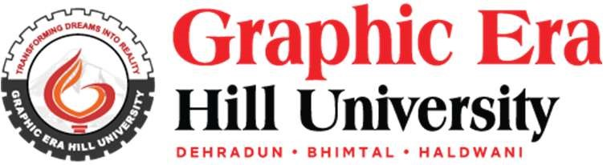
First Phase Presentation
PROJECT AND TEAM INFORMATION

Project Title

Language Conversion and Error Detection

Student / Team Information
Team Name: | Avengers
Team member 1 (Team Lead)  Name: Apratim Rana  Student ID: 23011535  Gmail: apratimrana234@gmail.com | 
Team member 2  Name: Kushagra garg  Student ID: 23011931  Email: kushgarg136@gmail.com | 
Team member 3  Name: Aditya Sharma  Student ID: 23011140  Email: Adityasharma270705@gmail.com | 
Team member 4  Name : Ayush Bisht  Student ID : 2300112800  Email : bishtayush409@gmail.com | 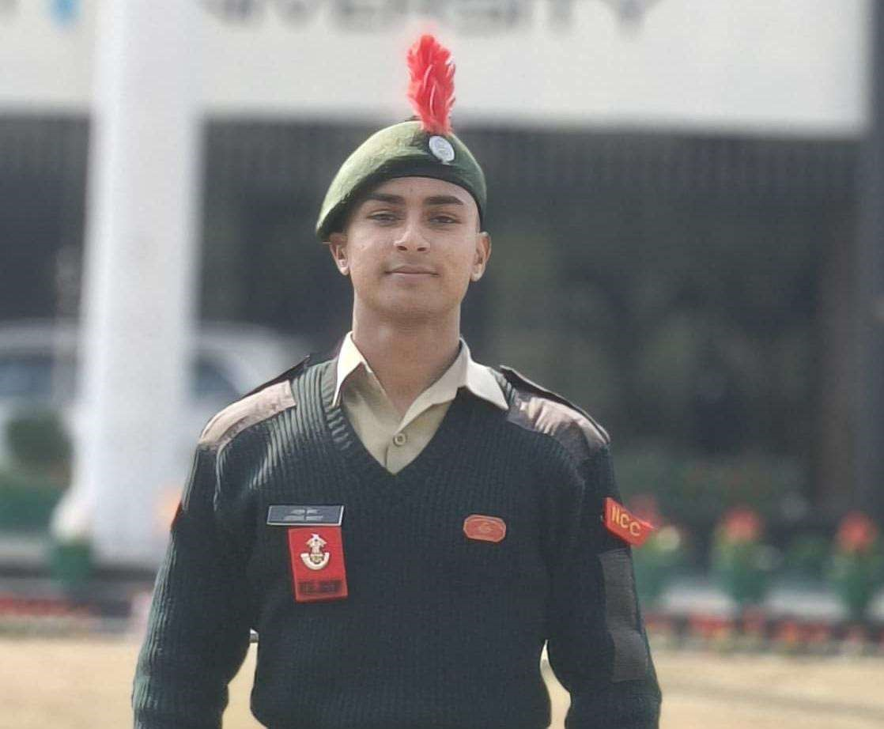
PROPOSAL DESCRIPTION

Motivation

Programming languages have different syntax, semantics, and execution models. Converting source code written in one language to another while preserving logic is a complex task that involves lexical analysis, parsing, semantic validation, and structured code generation. Manual conversion of C programs to Python is time-consuming and error-prone, especially for beginners who struggle with pointers, type declarations, memory handling, and syntax differences.
The problem addressed in this project is the automated translation of a subset of C programs into equivalent Python code along with compile-time style error detection. The system will identify lexical, syntax, and selected semantic errors in the C input and report them before generating Python output. This improves code reliability and demonstrates the practical implementation of compiler design concepts such as tokenization, grammar rules, symbol table handling, and intermediate representation.
This problem is important because it provides hands-on exposure to real compiler construction techniques rather than theoretical study alone. It also helps learners understand structural differences between procedural and dynamically typed languages. Additionally, such tools are useful in code migration, legacy system modernization, and educational environments where students learn multiple languages.
The project focuses on a well-defined subset of C (variables, loops, conditionals, functions, basic I/O) to keep the scope feasible while still demonstrating core compiler phases

State of the Art / Current solution

Existing tools such as transpilers and source-to-source compilers perform language conversion, but most are either full-scale industrial tools (e.g., Clang-based converters) or simple pattern-based scripts that do not perform proper parsing or error detection.
Online converters typically rely on heuristic or template matching and fail when the input contains nested structures, complex expressions, or syntax errors. They also do not provide detailed compiler-style diagnostics such as token mismatch, undeclared identifiers, or type inconsistencies.
Academic implementations often demonstrate only individual compiler phases (lexical analyzer or parser) rather than a complete pipeline that includes error handling and target code generation.
Therefore, there is a need for a structured educational tool that:
Implements full compiler phases
Detects errors before translation
Generates structured Python code
Works on a defined C grammar subset
This project fills that gap

Project Goals and Milestones
Goals: The primary goal is to design and implement a mini source-to-source compiler that:
- Accepts C code as input
- Performs lexical analysis and token generation
- Parses tokens using a defined grammar
- Detects syntax and selected semantic errors
- Maintains a symbol table for identifiers
- Generates equivalent Python code

The system must demonstrate all major compiler phases in a modular architecture.
Initial Milestones
Define the supported subset of C grammar
Implement lexical analyzer (tokens for keywords, identifiers, operators, constants)
Design context-free grammar for parser
Implement syntax analyzer (recursive descent or YACC/Bison)
Intermediate Milestones
Build symbol table for variables and functions
Implement semantic checks (undeclared variables, duplicate declarations, basic type checks)
Design intermediate representation (optional but recommended for structure)
Final Milestones
Implement code generator for Python output
Add error reporting with line numbers and meaningful messages
Test with multiple C programs (loops, conditionals, functions)
Optimize formatting and indentation for Python code
Prepare documentation and demonstration

Project Approach
The system will follow a modular compiler architecture:

Input C Program → Lexical Analyzer → Parser → Semantic Analyzer → Code Generator → Python Output

Technologies

- Language: C/C++ (preferred for compiler implementation) or Python
- Lexical Analysis: LEX/Flex (or manual tokenizer) • Parsing: YACC/Bison or Recursive Descent Parser
- Data Structures:
- Symbol Table (hash table)
- Token stream (linked list/array)
- Parse tree or Abstract Syntax Tree (AST)

Design Approach

Lexical Analyzer
Identifies tokens such as keywords, identifiers, operators, delimiters, and constants. Removes comments and whitespace.

Syntax Analyzer
Uses grammar rules for:
- variable declarations
- if-else statements
- for/while loops
- function definitions
- printf/scanf (mapped to Python I/O)
Semantic Analyzer Performs checks:
- undeclared variables
- multiple declarations
- basic type mismatch detection

Code Generator
Converts parsed structures into Python constructs:
- printf → print()
- for(int i=0; i<n; i++) → for i in range(n):
- braces {} → indentation
- type removal

Error Handling
Reports lexical and syntax errors with line numbers and halts code generation if critical errors are found.

System Architecture (High Level Diagram)
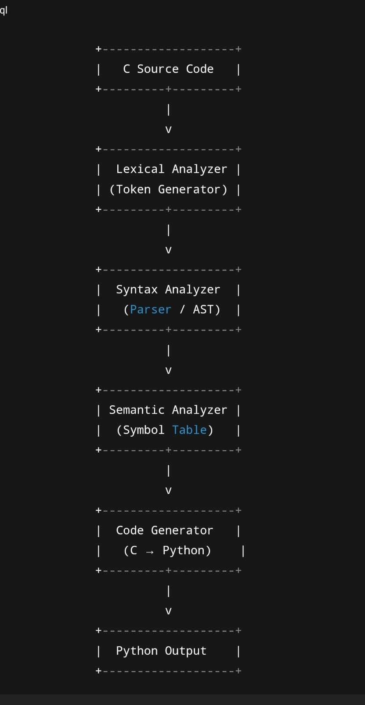

Project Outcome / Deliverables

Your answer here

Assumptions
The system will support a limited subset of C including basic data types, loops, conditional statements, functions without pointers, and simple I/O. Complex features such as pointers, dynamic memory allocation, structures, file handling, and preprocessor directives will not be translated. Input C code is assumed to be syntactically close to standard C without macros. Python output will preserve logic but may not replicate low-level memory behavior. Indentation will be autogenerated

References
- Lex & Yacc documentation – https://dinosaur.compilertools.net/
- Python Language Reference – https://docs.python.org/3/reference/ • C Language Reference – https://en.cppreference.com/w/c

